Experiment 1 C
Code:
import java.util.Scanner;

public class Main {
public static void main(String[] args) {

Scanner sc = new Scanner(System.in);

System.out.println("==============================");
System.out.println("MODULAR ARITHMETIC CALCULATOR");
System.out.println("==============================");

System.out.print("Enter the 1st Integer (a): ");
int a = sc.nextInt();

System.out.print("Enter the 2nd Integer (b): ");
int b = sc.nextInt();

System.out.print("Enter the Modulus (m): ");
int m = sc.nextInt();

if (m <= 0) {
System.out.println("Modulus must be greater than 0.");
} else {

while (true) {

System.out.println("\n====== MENU ======");
System.out.println("1. Modular Addition");
System.out.println("2. Modular Subtraction");
System.out.println("3. Modular Multiplication");
System.out.println("4. Modular Exponentiation");
System.out.println("5. Exit");

System.out.print("Enter your choice (1-5): ");
int choice = sc.nextInt();

if (choice == 1) {
int result = (a + b) % m;
System.out.println("\nModular Addition");
System.out.println("(" + a + " + " + b + ") mod " + m + " = " + result);

} else if (choice == 2) {
int result = (a - b) % m;
System.out.println("\nModular Subtraction");
System.out.println("(" + a + " - " + b + ") mod " + m + " = " + result);

} else if (choice == 3) {
int result = (a * b) % m;
System.out.println("\nModular Multiplication");
System.out.println("(" + a + " * " + b + ") mod " + m + " = " + result);

} else if (choice == 4) {
long result = 1;

for (int i = 0; i < b; i++) {
result = (result * a) % m;
}

System.out.println("\nModular Exponentiation");
System.out.println("(" + a + "^" + b + ") mod " + m + " = " + result);

} else if (choice == 5) {
System.out.println("\nExiting the program");
break;

} else {
System.out.println("\nInvalid choice! Please select between 1 and 5.");
}
}
}

sc.close();
}
}
Output:
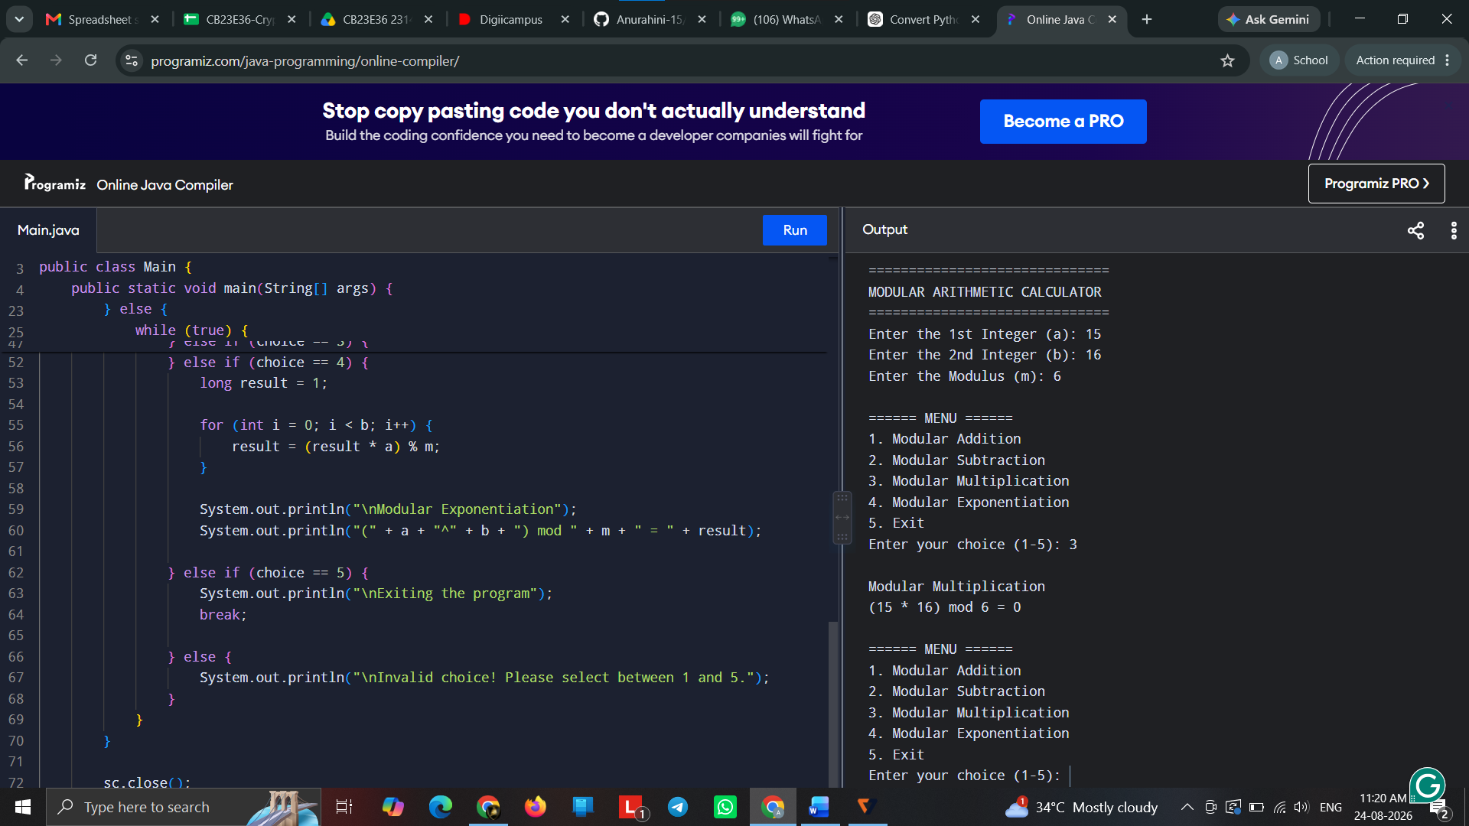

Experiment 1 D
Code:
import java.util.Scanner;

public class Main {
public static void main(String[] args) {

Scanner sc = new Scanner(System.in);

System.out.println("=============================");
System.out.println("RSA PRIME VALIDATION USING FERMAT'S TEST");
System.out.println("=============================");

System.out.print("Enter the value of a: ");
int a = sc.nextInt();

System.out.print("Enter the candidate prime number (p): ");
int p = sc.nextInt();

if (p <= 1) {
System.out.println("\nInvalid input");
System.out.println("The candidate number p must be greater than 1");
} else {

long result = 1;

// Calculate (a^(p-1)) mod p
for (int i = 1; i <= p - 1; i++) {
result = (result * a) % p;
}

System.out.println("\nResult of Fermat Test");
System.out.println("(" + a + "^" + (p - 1) + ") mod " + p + " = " + result);

if (result == 1) {
System.out.println("\nThe number satisfies Fermat's Little Theorem");
System.out.println("It is a probable prime");
System.out.println("Candidate is suitable for further RSA key generation");
} else {
System.out.println("\nThe number does not satisfy Fermat's Little Theorem");
System.out.println("It is composite.");
System.out.println("Candidate is not suitable for RSA key generation");
}
}

sc.close();
}
}
Output:
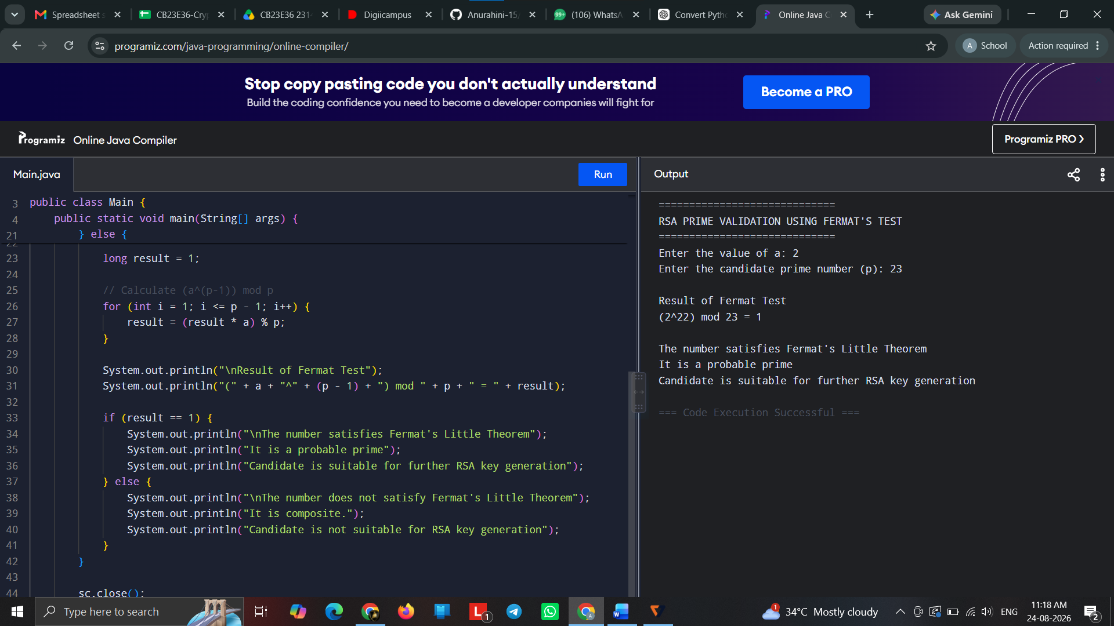

Experiment 1 E
Code:
import java.util.Scanner;

public class Main {
public static void main(String[] args) {

Scanner sc = new Scanner(System.in);

System.out.println("==============================================");
System.out.println("Military Secure Communication System");
System.out.println("==============================================");

System.out.print("Enter the 1st Communication Parameter: ");
int parameter1 = sc.nextInt();

System.out.print("Enter the 2nd Communication Parameter: ");
int parameter2 = sc.nextInt();

int a = parameter1;
int b = parameter2;

while (b != 0) {
int remainder = a % b;

System.out.println(a + "/" + b +
" = Quotient " + (a / b) +
", Remainder " + remainder);

a = b;
b = remainder;
}

int gcd = a;

System.out.println("\nGreatest Common Divisor (GCD) = " + gcd);

if (gcd == 1) {
System.out.println("\nThe communication parameters are COPRIME");
System.out.println("Secure communication can be established");
} else {
System.out.println("\nThe communication parameters are NOT COPRIME");
System.out.println("Communication setup rejected");
}

sc.close();
}
}
Ouput:
